

**Quiz Game Project Report**

**Submitted To:**

**Soumik Das Bibon**

**Department of CSE**

**Daffodil International University**

**Submitted By:**

**Name: Md. Ebrahim Joy**

**Id. 151-15-5112**

**Sec: I**

**Date of Submission:** 10-12-2016

Contents:

Abstract

Introduction

Uniqueness

Instruction

Screenshot

Obstacles

Future plan

Conclusion

Abstract:

This is the project of quiz game. Here player gets three lives/chances to play, that means player can give two wrong answers but if he/she gives 3rd wrong answer the game will go to the end.

Introduction

We all are familiar about quiz game. In this game a player can choose his/her subject from the content. Then the player will found some questions and several options. From the options player should choose the right one. If he/she choose right one, then program will display “Your answer is right” on the other side if player choose wrong one then program will display “Your answer is wrong”. By this method player plays this game. If the player gave three wrong answer then program go to the end until this happened player can play the game. If player can complete the game, program will display congratulation otherwise failed.

Uniqueness

Every new project needs some uniqueness. In my project my uniqueness is three lives/chances. Also my project based on 4th subject such as data communication, Numerical method, Microprocessor & assembly language and Bio-informatics. After complete the game you can again go to main menu or exit.

Instruction

In my project I used many instructions. Here I used mov,offset,ah1,ah2,ah,9,al,int21h,cx,many_level,jmp,je, end, and many more.

Here offset used for call the message that I declare first. Ah,1 used for input a number/character from keyboard. Ah,2 used for output number/character in output screen. Int21h used for interrupt a program. CX (Counter register)used for count. Then here I used many level for complete the program in separate way but so easily. Jmp used for jump a level to other level. Je used for jump a level to other level but when 1st and 2nd statement is equal. Lastly I used end for ending my project.

Screenshot:

This is the first look of my program. Here I initialized or declare all my messages, questions and options. In later my program I called this messages, questions and options by using offset.

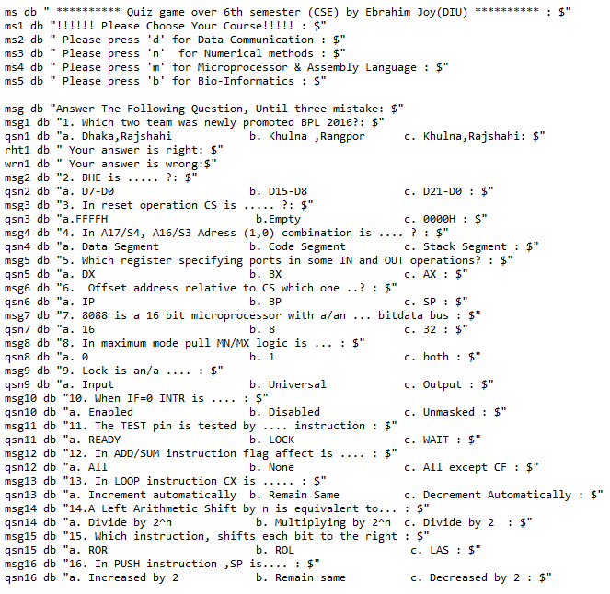

In this picture I displayed the how I count the three lives. Here firstly I set CX=0 the when player enter any wrong answer I increased CX by one. And when CX=3 program go to the end.

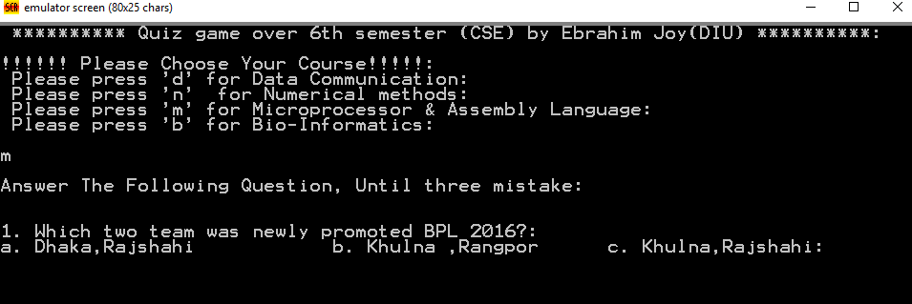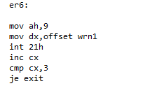This is the output screenshot of my program. Here player can choose any subject. Through his/her chosen subject program asked him/her many question.

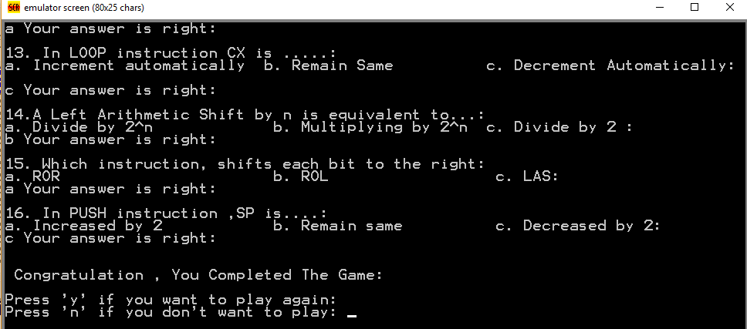In my last screenshot, I displayed the congratulation part. If any player complete the game without three mistakes then he/she will seen this output.

Obstacles:

To complete my project I faced many problems. Firstly how I set the lives/chances in my code. How kind of question I will choose. How can I compare the register. As the code is more than 1400 lines so I faced to running problem cause when I need to check my code I need to run again and again.

Future Plan:

In my project I only complete the microprocessor subject. In future I will add all the four subjects. Also I want to use time for per question. At end of my program I will add the score depends on the time.

Conclusion:

This quiz game is interesting game. Besides this we require more knowledge about that subject. It helps to sharp our brain. If I completed my game with my future plan, then it will very helpful to us.